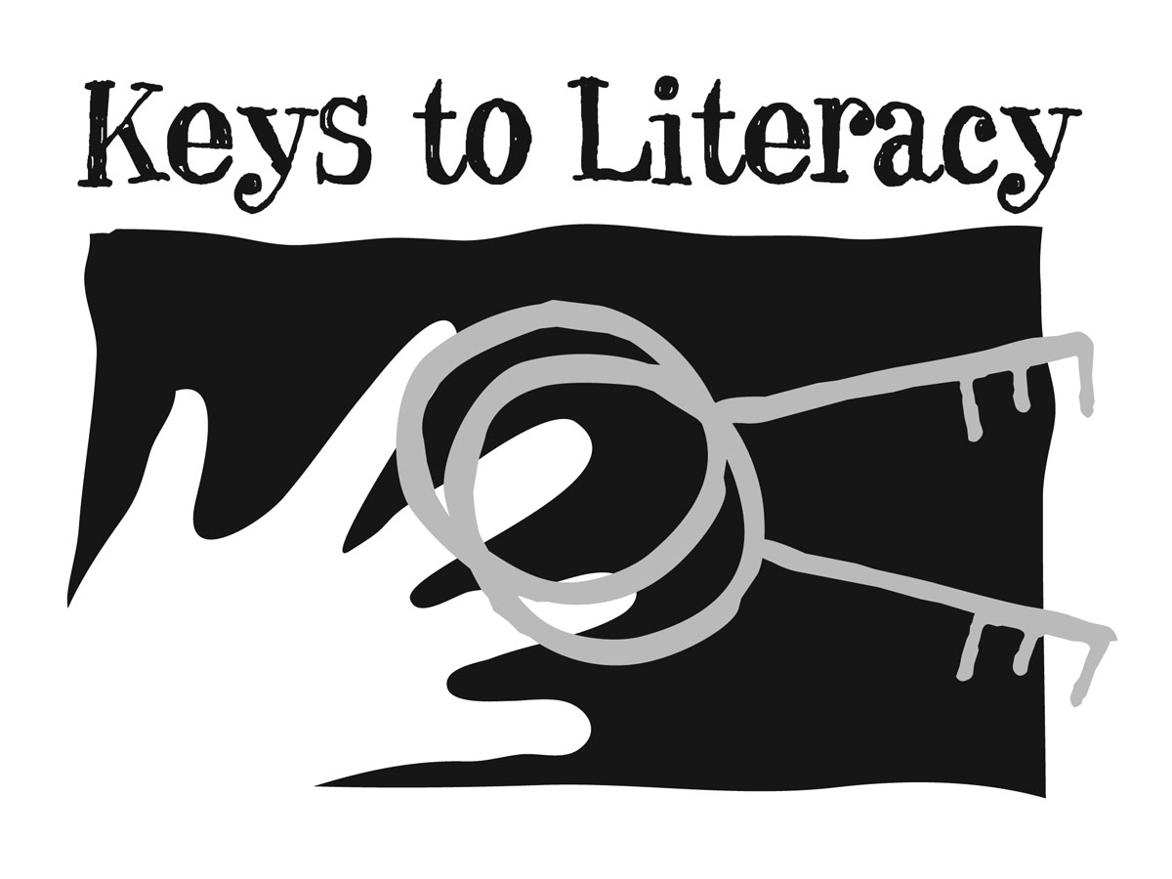

Professional Book Discussion Guide

Book Title: The Key Comprehension Routine, Grades 4-12 (2015 edition)

Summary of Book: This is the training book used during professional development for “The Key Comprehension Routine”. Part I provides an overview of the program and best practices for effective comprehension. Part II presents instructional suggestions that make up the teaching routine for teachers (critical thinking, text structure, I, We, You instruction, main idea skills). Part III provides details about the four comprehension strategies that make up the student routine: (1) Top-Down Topic Webs, (2) Two-Column Note Taking, (3) Summarizing, (4) Question Generation. Part IV shows how the strategies can be combined and offers suggestions for school-wide implementation.

Part I

Chapter 1: What is The Key Comprehension Routine?

- What are the four instructional practices that make up the teaching routine and the four strategies that make up the student routine?
- Describe who is receiving professional development for this program in your school or district. Will a sufficient number of teachers use the program to provide consistency as students move from grade to grade and subject to subject?
- Complete the activity related to the list of Common Core literacy standards, then share your response with colleagues.
- Review the findings from the National Staff Development Council Report about effective professional development. Consider the professional development you have received over the past five years – how many of the elements of effective training were incorporated? Share your response with colleagues.

Chapter 2: Comprehension Instruction

- If a student has weak decoding and fluency skills, how might this affect his reading comprehension?
- If a student’s vocabulary knowledge is insufficient for his grade level, how might this affect his reading comprehension?
- What are the major strategies that have been identified in the research as most effective for improving comprehension?
- Complete the activity “Current Use of Comprehension Strategies”. Are any of the strategies you listed aligned with those suggested in the research?
- Do you agree with this statement: “Content teachers may be in the best position to teach comprehension strategies because they know best how to read and write in their subject area (e.g., science, history, math, literature)”. Explain why or why not.

Part II

Chapter 3: Critical Thinking

- Review the information about the increased level of close reading and critical thinking skills required in the Common Core State Standards, including the chart in Figure 3A. Share your reactions to this information with colleagues.
- What is the difference between general comprehension strategy instruction and disciplinary literacy instruction?
- Define the term meta-cognition and explain why teachers should be familiar with this term.
- Can you think of an example when you explicitly taught a skill to students by using modeling and think aloud?
- Describe what is meant by a critical thinking taxonomy, and give two examples. Does your school or district emphasize any of the common taxonomies?

Chapter 4: Text Structure

- What is the difference between text features and text structures? Provide two examples of each.
- What are the three major types of text? For each type, describe its purpose and how it is organized.
- How would you explain to students what transitions are and why they help comprehension and writing? Do you already provide a list of transitions to your students? If not, would you consider using the list provided in the book?
- What are the five major patterns of organization, and can you identify two transitions that might signal each type?
- Explain to a colleague why complex sentences might negatively affect a student’s comprehension. Can you find an example in your classroom reading of a complex sentence that might be difficult for your students to comprehend?
- Do you think most of your students have a solid understanding of paragraph structure?
- Complete the activity “Your Content Reading Structure” and share the results with colleagues.
- Explain to a colleague why explicit instruction of text structure helps students’ comprehension.

Chapter 5: I, We, You Instruction

- Explain the term differentiation. Give an example of a time when you differentiated your classroom instruction.
- Explain to a colleague the three main phases in the I, We, You model of instruction.
- Review the examples of explicit instruction in Figure 5B and then select one from each section that you are most interested in learning how to teach.
- What are the four ways to scaffold, as suggested by Dickson, Simmons, and Kame’enui?
- Complete the activity at the end of the chapter. Then share with a colleague the names of the students you identified.

Chapter 6: Main Idea Skills

- What are some terms that are associated with main idea skills?
- Complete the activity “Everyday Examples” and share your response with colleagues.
- Review the scope and sequence for teaching main ideas. Why do you think the simplest level is categorizing?
- Take turns with a partner explaining the three techniques for finding the main idea (i.e, Goldilocks, Label the Bucket, Self-Cuing).
Review the example of vocabulary categorizing in Figures 6E, F,G,H, I. Then complete the activity “Categorizing Academic Vocabulary.” Then complete the activity “Your Content Vocabulary.” Share your responses with colleagues.
- Explain why a paragraph with an implied main idea might be more difficult to comprehend than a paragraph with a stated main idea.
- Complete the activity “Identify the Paragraph Main Idea”.
- Explain how finding the main idea of a paragraph is similar and different from finding the central idea of multi-paragraph text.
- Complete the activity “Use Your Content” to generate a central idea.
- Describe the three suggestions for scaffolding main idea instruction.
- Think of a main idea task you can use in your classroom.

PART III

Chapter 7: Top-Down Topic Webs

- Make a list of graphic organizers you use on a regular basis with students.
- Do you agree with this statement by the author: “However, the availability of so many different types of graphic organizers often results in confusion about when and how to use them. As they move from class to class and encounter teachers using different kinds of graphic organizers, students become overwhelmed and tend to focus more on figuring out how to use each new template instead of how to generate their own graphic organizer to help learn information.”
- How would you best describe a top-down topic web and why visual elements such as shape, color and position are important?
- Generate a top-down topic web that is based on a content reading sample from your classroom. Then develop a partially completed version of the topic web as a scaffold for students.
- Generate a top-down topic web that is based on a unit of study you will cover in your classroom. Then take one section of that unit and develop a sub-web.
- Summarize how the teacher can use a top-down topic web as a before, during, and after teaching strategy.
- Review the classroom examples at the end of the chapter. Did any of them give you some ideas for how you might use topic webs in your teaching?

Chapter 8: Two-Column Notes

- How would you best describe to students the format of two-column notes?
- The author describes some advantages that the two-column format has over traditional outlining for taking notes. Do you agree or disagree?
- Why is it important for students to have strong main idea skills in order to take good notes?
- Give some examples of non-text and text sources from your classroom from which notes might be taken.
- Complete the activity “Notes From Paragraphs” then share your notes with a colleague.
- Which of your students might benefit from you providing partially completed two-column notes before they take notes from reading or a lecture?
- Explain what the author means by note taking “sub-skills” and describe your students’ ability to apply these sub-skills when taking notes.
- Identify two content vocabulary terms that are essential for students to learn. Develop a two-column entry for each term.
- What suggestions does the author provide for introducing and scaffolding note taking from lectures?
- Complete the activity “Create a Set of Two-Column Notes”, then share your response with a colleagues.
- Review the classroom examples at the end of the chapter. Did any of them give you some ideas for how you might use two-column notes in your teaching?

Chapter 9: Summary

- In your own words, explain to a colleague how a sponge can be used as a metaphor for writing a summary.
- Explain how a summary is different from a retell. Explain why summary skills help comprehension and writing skills.
- Give some examples of non-text and text from your classroom that can be summarized.
- Review the summary steps in Figure 9E. Do you think this set of steps might be helpful for your students? If so, think of a way you can make this list accessible to students in your classroom.
- Why is it important for students to have strong main idea skills in order to generate good summaries?
- Explain to a colleague why summary writing is difficult for many students. What sub-skills must be integrated?
- Can you use the summary template in your classroom? If not, how could you adapt it so you could?
- Explain how a top-down topic web or a set of two-column notes can be used to generate a summary.
- Complete the activity at the end of the chapter; share your summary from notes with colleagues.

Chapter 10: Question Generation

- Explain in your own words why teaching students to generate and answer questions can be a powerful comprehension strategy.
- What are the six levels of thinking that make up Bloom’s Taxonomy? Do you incorporate Bloom’s Taxonomy in some way in your teaching?
- Review the question terms in Figure C. Identify and circle 5 essential question terms that you will teach students as soon as possible.
- Can you use the list of terms in Figure C and the list of question prompts in Figure D in your classroom? If not, how could you adapt them so you could?
- Review the suggestions provided in Figure 10E for gradually releasing responsibility to students for generating questions. Do you agree with the order of the suggestions?
- Complete the activities “Generate Your Own Questions” and “What Level?”. Share your resonses with colleagues.
- Explain how a top-down topic web or a set of two-column notes can be used as the basis for question generation.
- Identify a content reading selection and generate one question at every level of Bloom’s Taxonomy.
- Review the classroom examples at the end of the chapter. Did any of them give you some ideas for how you might use question generation in your teaching?

Part IV

Chapter 11: Combining Activities

- Explain to a colleague what the arrows in Figure 11A represent. How are the four strategy activities connected?
- Review the four examples of the application of the routine (ELA, social studies, science, math examples). Then think of how you might combine a top-down topic web, two-column notes, summary, and question generation to content reading material you use in your classroom.

Chapter 12: Review

- Take turns with a colleague summarizing the purpose of topic webs, two-column notes, summarizing, and question generation, and how they can be used as before, during, and after strategies.
- Complete the “Reflection Activity”: How will the Key Comprehension Routine change my teaching? How will the Key Comprehension Routine change my students?
- Which of the teaching practices from this book are already areas of strength for you as a teacher? In which area(s) do you intend to grow?
- What is the most practical take away that you will implement in your classroom as soon as possible?

